## 

|  |
| --- |
| ### comparison qplot vs ggplot# qplot histogramqplot(clarity, data=diamonds, fill=cut, geom="bar")# ggplot histogram -> same outputggplot(diamonds, aes(clarity, fill=cut)) + geom_bar() |

|  |
| --- |
| # use different display of bars (stacked, dodged, identity)  head(diamonds)  qplot(clarity, data=diamonds, geom="bar", fill=cut, position="stack")  qplot(clarity, data=diamonds, geom="bar", fill=cut, position="dodge")  qplot(clarity, data=diamonds, geom="bar", fill=cut,  position="fill")  qplot(clarity, data=diamonds, geom="bar", fill=cut,  position="identity")  qplot(clarity, data=diamonds, geom="freqpoly", group=cut, colour=cut, position="identity")  qplot(clarity, data=diamonds, geom="freqpoly", group=cut, colour=cut, position="stack") |

## 

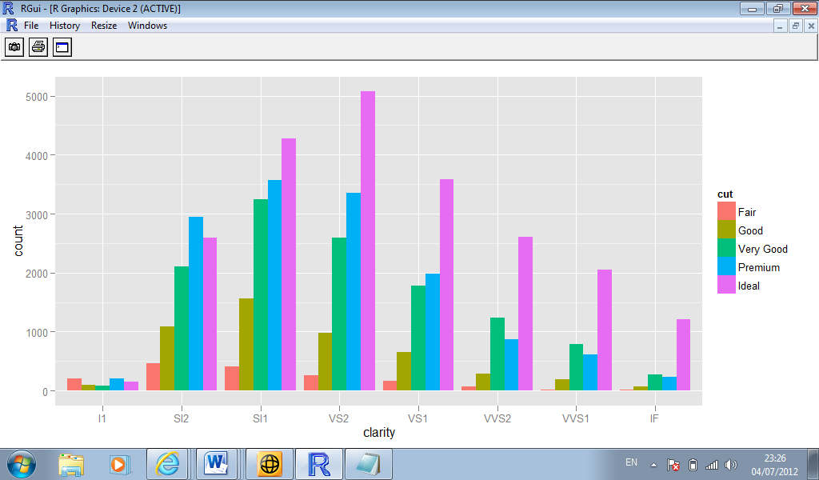

## 

## 

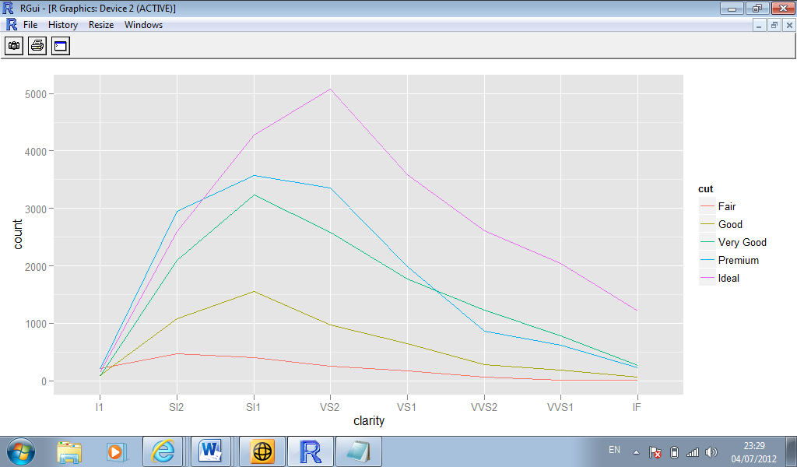

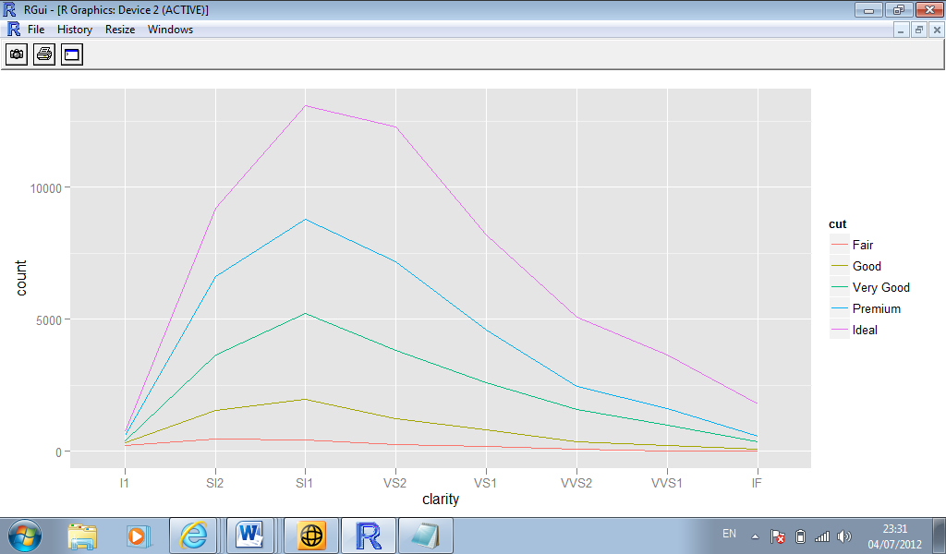

## 5.2 Overall Layering strategy

1. to display data
2. to display a statistical summary of the data
3. to add additional metadata, context and annotations

## 5.3 Basic Plot Types

|  |
| --- |
| P+ geom_line() + opts|(title=”geom_line”)  P+geom_line() + opts(title="geom_line")  P+geom_area() + opts(title="geom_area”)  P+geom_text() + opts(title="geom_text")  P+geom_tile() + opts(title="geom_tile")  P+geom_polygon()+ opts(title="geom_polygon") |

## 5.4 Displaying distributions

|  |
| --- |
| Depth_dist +  Geom_histogram  Depth_dist + geom_histogram(aes(fill=cut),binwidth =0.1,position =”fill”) |

## 5.5 Dealing with overplotting

## Narrower glyphs

## Jitter

* Alpha blending

## 5.6 Surface plots

* Ggplot2 does not support 3d graphics.
* However it does support ways of presenting 3d surfaces in 2d: contour plots, coloured tiles and bubbleplots.

## 5.7 Map Data

Ggplot2 has incorporated some tools that make it easy to combine maps into projects, for example the borders () function.

## 5.8 Revealing uncertainty

|  |  |  |
| --- | --- | --- |
| X variable | Range | Range + Centre |
| Continuous | geom_ribbon | geom_smooth(stat=”identity”) |
| Discrete | geom_errorbar | geom_crossbar |
|  | geom_linerange | geom_pointrange |